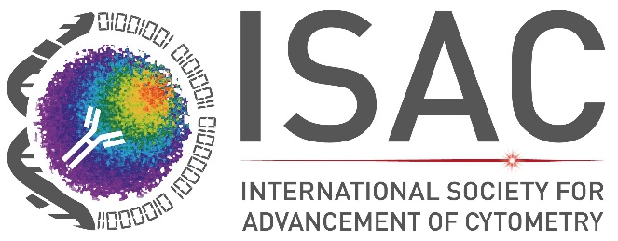

Dear ,
We would like to extend an invitation to you to attend CYTO 2027 the 40th Annual Congress of the International Society for Advancement of Cytometry (ISAC) scheduled June 5 – 9, 2027, at the Helsinki Expo and Convention Centre in Helsinki, Finland.
The program includes Frontiers Lectures & Plenary Talks, State-of-the-Art Lectures, Scientific Tutorials, Commercial Tutorials, Parallel & Poster Sessions, The Hooke Lecture, Commercial Exhibits, Interest Development Groups and Networking Opportunities.
Visa requirements may vary depending on your country of origin. Please be sure to check the Embassy in your area regarding visas and required travel documents well in advance of the meeting.
We are eagerly looking forward to welcoming you to Helsinki for CYTO 2027 and are confident that your presence will make a significant contribution to the success of the congress.
Sincerely,



Lanie Lesko
Director of Meetings
International Society for Advancement of Cytometry (ISAC)
700 Pennsylvania Ave SE
Washington, DC 20003
llesko@isac-net.org

